Burpien

Requirements Document

V1.0

Introduction

This is a cashier register system. This system is more flexible as you can create your own user interface in it. It allows for multiple users and has a privilege system in place which can be granted to the sub-users. This cashier register system is used for places like restaurants and grocery stores.

Glossary

User: is the person utilizing the system.

Sub-user: is the person utilizing the system but with constrained privileges.

Privilege: how much authority the user has and how much changes they can do to the system.

Item: is the product to be sold or displayed on the item menu.

Category: is the container of a set of items.

Basket: the list of items ordered/in order.

Order: is the container of all the information concerning the order such as, the order id, the basket, user id, and payment details.

Functional Requirements

|  |
| --- |
| New Order |
| Prerequisite: |
| User/sub-user is logged in  User/sub-user is in Main Page |
| Steps:   1. User clicks on “new order” button 2. A new order gets created |

|  |
| --- |
| Cancel Order |
| Prerequisite: |
| An order was made |
| Steps:   1. User clicks on “cancel” button 2. The order details and the order itself gets deleted. |

|  |
| --- |
| Pay |
| Prerequisite: |
| An order was made  There are items in basket |
| Steps:   1. In the basket field, user clicks pay 2. A Pay Page appears 3. User fills in payment details 4. Clicks pay and the order becomes “closed” |

|  |
| --- |
| Log in |
| Prerequisite: |
| User/sub-user is not logged in already  User/sub-user is in Main Page |
| Steps:   1. Click on Log in/out button 2. Page will transfer to Log in/out page 3. User inters id using on-screen num-pad. 4. User clicks log in button 5. Systems checks 6. If credentials are correct, then page will transfer back to main page with id and name displayed on the main page top 7. Items menu gets populated with the interface (the items and categories) |

|  |
| --- |
| Log out |
| Prerequisite: |
| User/sub-user is logged in  User/sub-user is in Log in/out Page |
| Steps:   1. Click on Log in/out button 2. Page will transfer to Log in/out page 3. User clicks log out button 4. page will transfer back to main page with id and name removed on the main page top 5. Items menu will get unpopulated and becomes empty |

|  |
| --- |
| Create User Interface (Create) |
| Prerequisite: |
| User/sub-user is logged in with super-privilege/root  User/sub-user is in Main Page |
| Steps:   1. A logged in privileged user clicks on create button on the top 2. The page transfers to the Creation Page 3. If there exists an interface, it will be loaded. Otherwise, an empty one will be created. 4. User makes modification: add, delete and modify the interface. 5. User clicks Save and the created interface will be saved. 6. The system transfer the user back to the main page and populate it with the interface. |

|  |
| --- |
| Create Item (Create) |
| Prerequisite: |
| Input Fields are filled in  User/sub-user is in Creation Page |
| Steps:   1. User clicks on “items” tab 2. User selects the type of item 3. User populate the required fields 4. User clicks create. |

|  |
| --- |
| Remove Item (Create) |
| Prerequisite: |
| An item in the editor is selected  User/sub-user is in Creation Page |
| Steps:   1. User clicks the “info” tab 2. User selects/clicks on the specified item/category 3. The item’s information gets populated in the info tab 4. User then clicks delete  * If selected is a category: if empty, category will be deleted. If it has items in it, deletion will be denied. * If selected is an item: item will be deleted directly. |

|  |
| --- |
| Modify Item (Create) |
| Prerequisite: |
| An item in the editor is selected  User/sub-user is in Creation Page |
| Steps:   1. User clicks the “info” tab 2. User selects/clicks on the specified item/category 3. The item’s information gets populated in the info tab 4. User makes changes to the item information 5. User then clicks save |

|  |
| --- |
| Add Item (basket) |
| Prerequisite: |
| An order was created  User/sub-user is in Main Page |
| Steps:   1. User clicks on the item wanted from the item menu on the left 2. The item will be added to the basket  * For multiple entries, user clicks how many times the item is wanted. * For items with a price per weight, a small window will show up to ask for the weight. |

|  |
| --- |
| Remove Item (basket) |
| Prerequisite: |
| An order was created  There are items in the basket  Order status is “open” |
| Steps:   1. User clicks on “modify” button in the basket field to go to modify mode. 2. Red buttons will show on the right of the items. 3. User clicks the items. 4. The items get removed from the basket. 5. User clicks done to go to regular mode. |

Non-Functional Requirements

* System should come with a root/super-privileged user. With each user having a special id.
* Only root/super-privileged users can
  + create sub-users
  + create interfaces and add/remove/modify categories and items
  + grant privileges.
* A user must be logged in for a new order to be created.
  + New orders should record the user id.
  + The basket
  + The payment details
* An Order has two states “open” and “closed”
  + Open: the order is open and can be modified
  + Closed: the order was payed for and cannot be modified.
* Once categories have items in them, they can not be deleted, but can be renamed.
* Items can not be created unless there is a category created beforehand.
* To create a category only a name is required. As for an items, the name, price, unit of price, and a category are required. The barcode is not required.

Future Enhancement

* Support for external tools such as:
  + Barcode scanner
  + Scale
* User creation with privilege granting.
* Payment page
  + The types of payment
  + Type accepted or not
  + Receipt printing
    - In case of payment failure, print a failure receipt.
* Interface files loading
  + Load existing interfaces from files.
  + Interfaces include users created.
* Database for storage of orders, users, and interfaces.
* Previous/next order viewing buttons
  + Will populate the basket field with the selected order’s recorded basket.
* The items has an option to show pictures too.
  + Add picture to items in creation page.
  + Picture shows up inside the button indicating the item.

Graphical User Interface

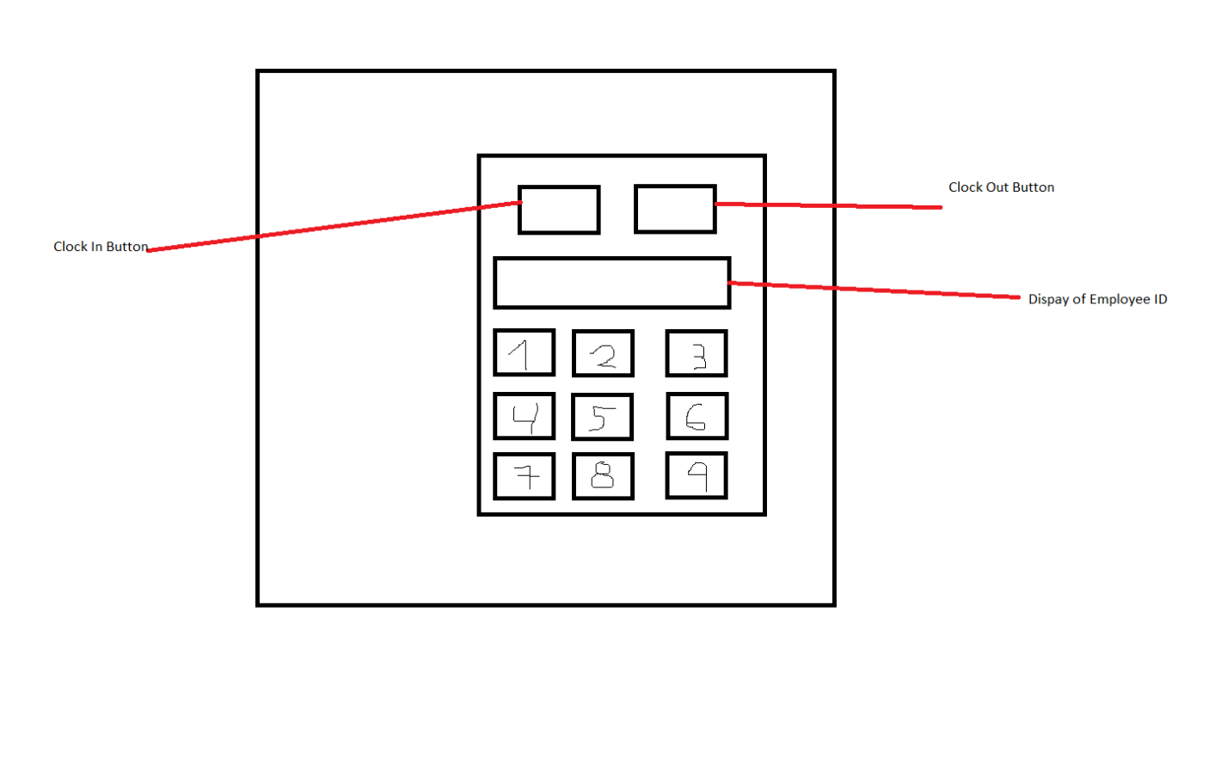

Example 1: As for the system, when a user wants to use the cashier it will be required to log in with proper credentials in order to access the system.

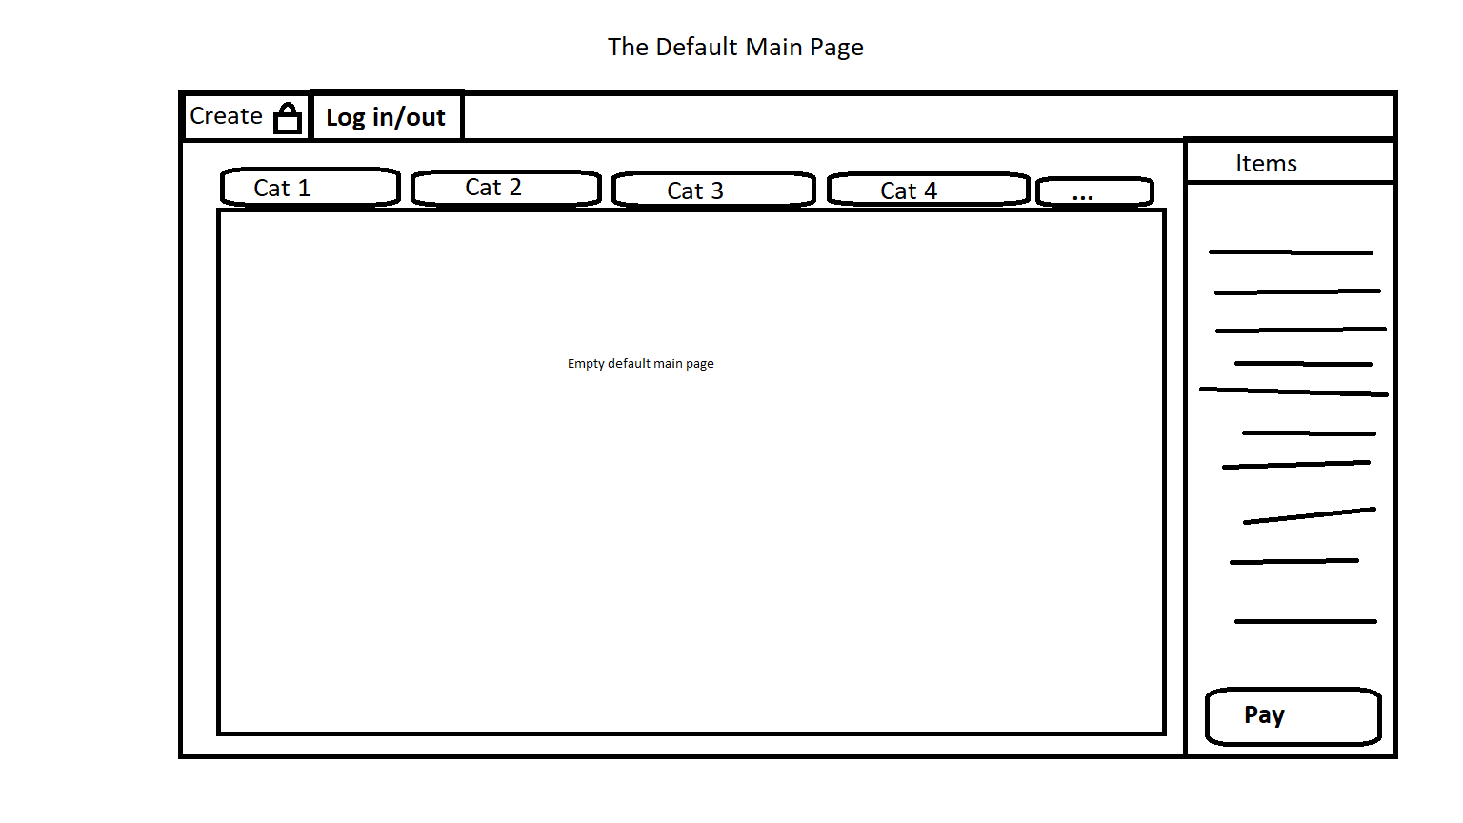

Example 2: After successfully logging in, the screen will display the users id and a screen that appears to be empty, but it will fill as a customer makes more orders.

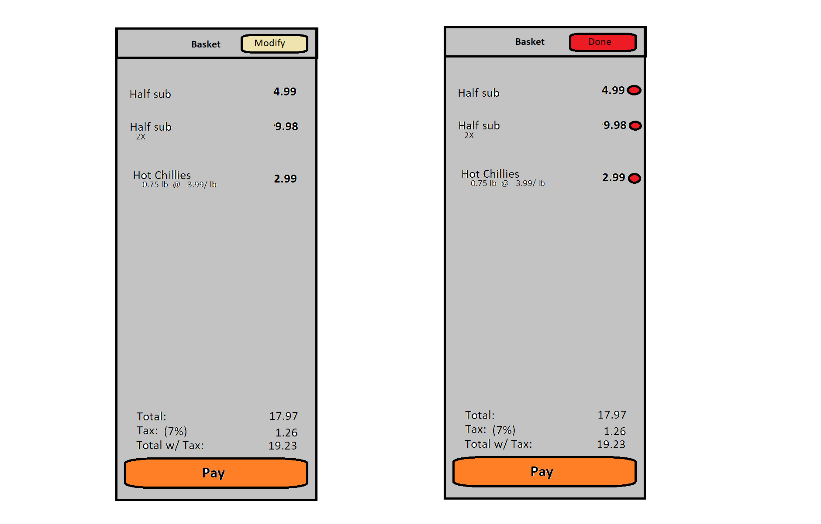

Example 3: Once a customer makes an order, the column with items with be updated to show what items have been chosen, the quantity of them and their price, this section can be used to manually add or remove items from the tally.

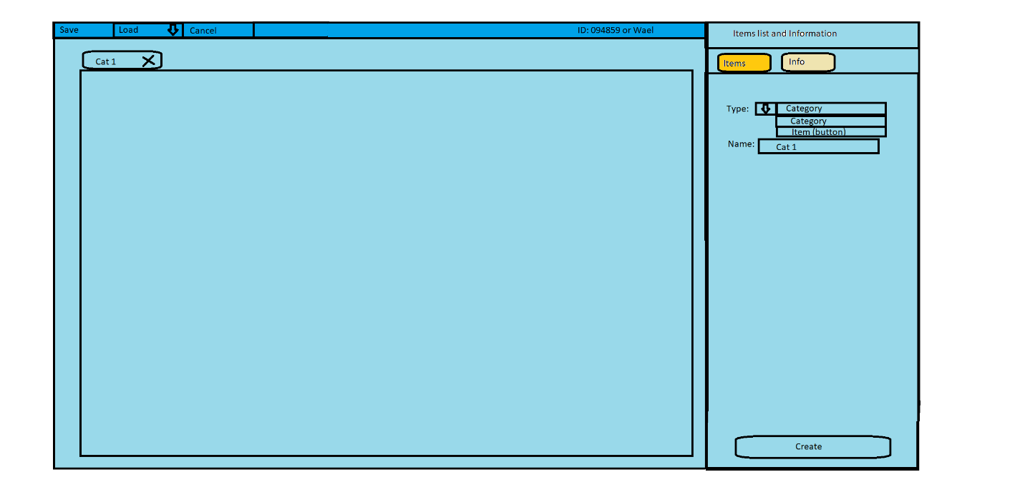

Example 4: Finally, the system has a feature for people with special credentials that will allow them to add or remove buttons from the main screen, a feature only people with super privilege can access as it can affect how the main screen looks and the features it can have.

